PEPP Invoice Letter #6 – Administration Fee not included

With respect to Regression Testing the PEPP Invoice Letter #6 for Release 22.4.1, the Administration (Late) Fee is not included in the invoice.

Scenario 1: Living Skies Housing Authority

Had 2 instances of Late Remittances between April 1, 2022 to date. The DCT screenshot below is the 2nd instance and the letter/invoice being reviewed.

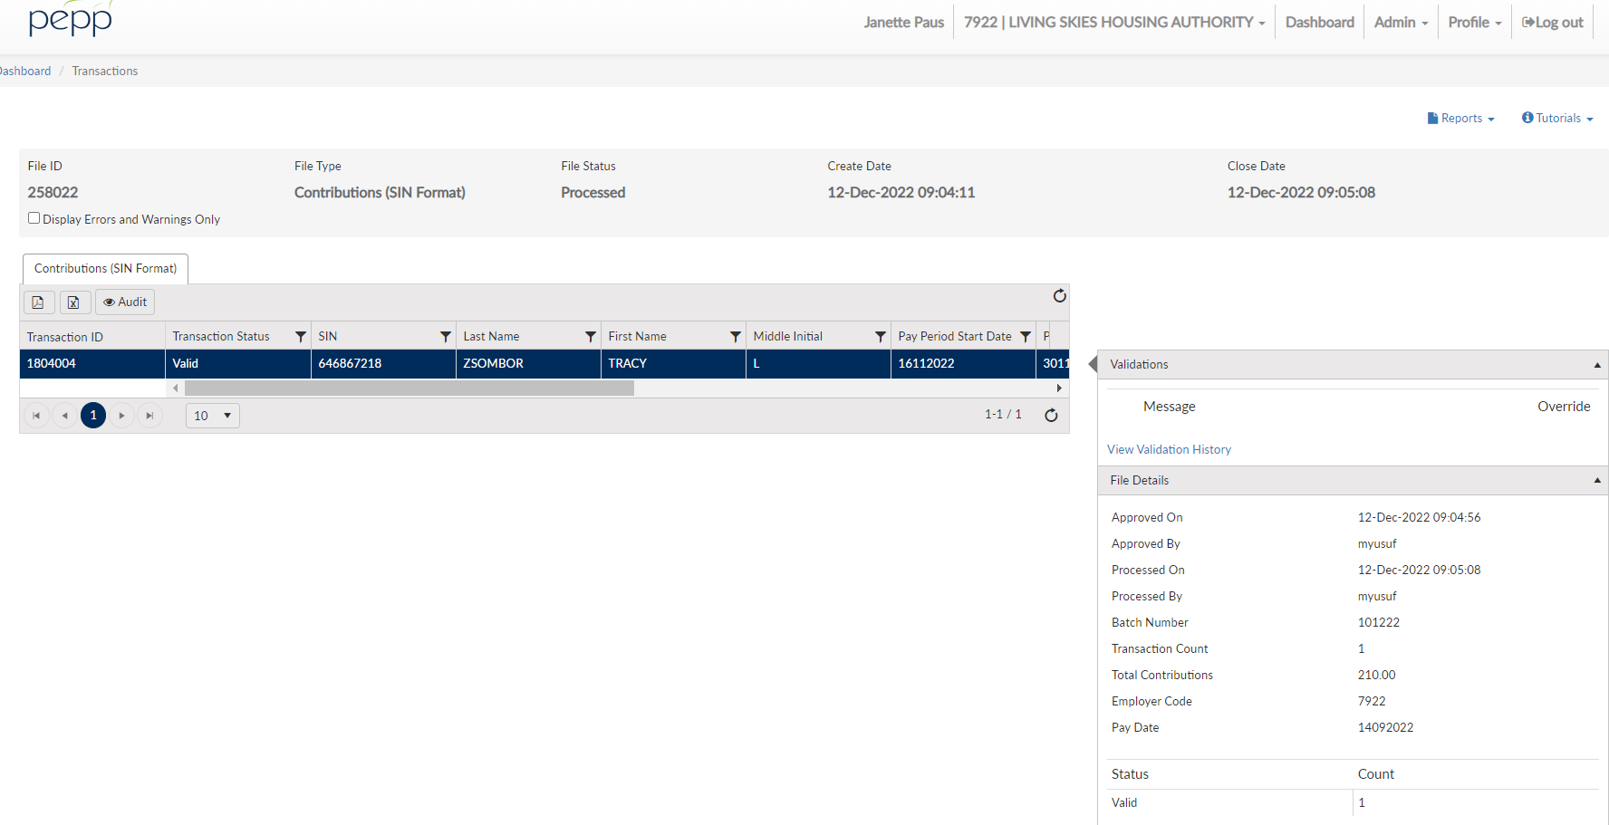

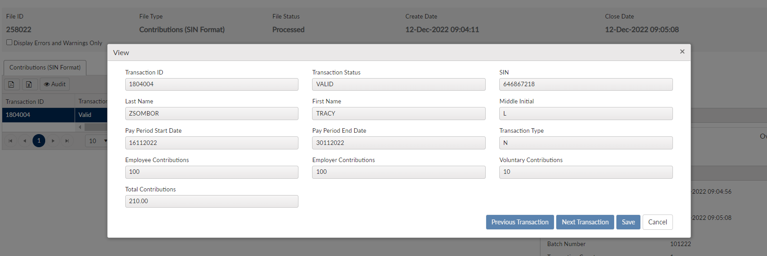

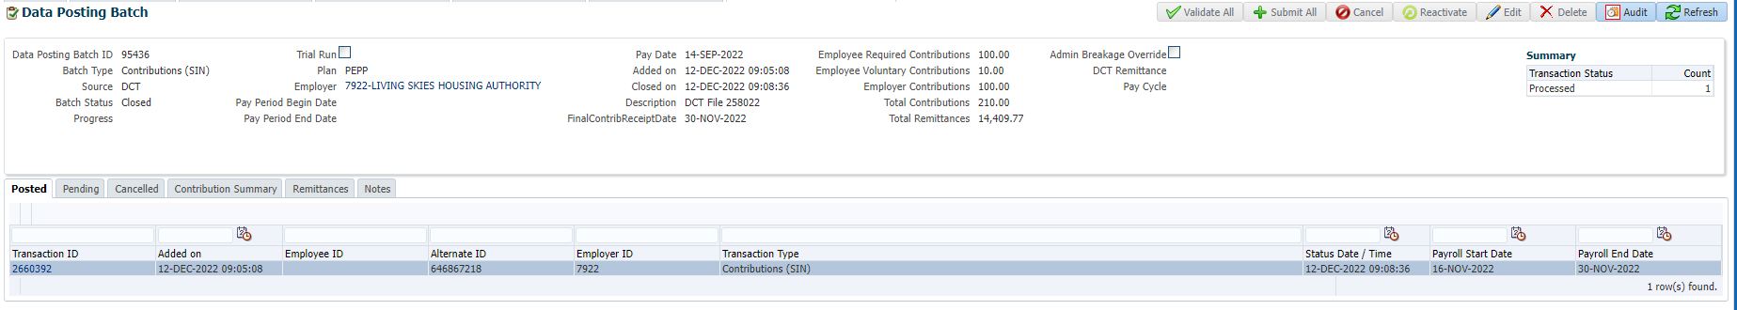

There is Employer Negative Breakage and Administrative Positive Breakage:

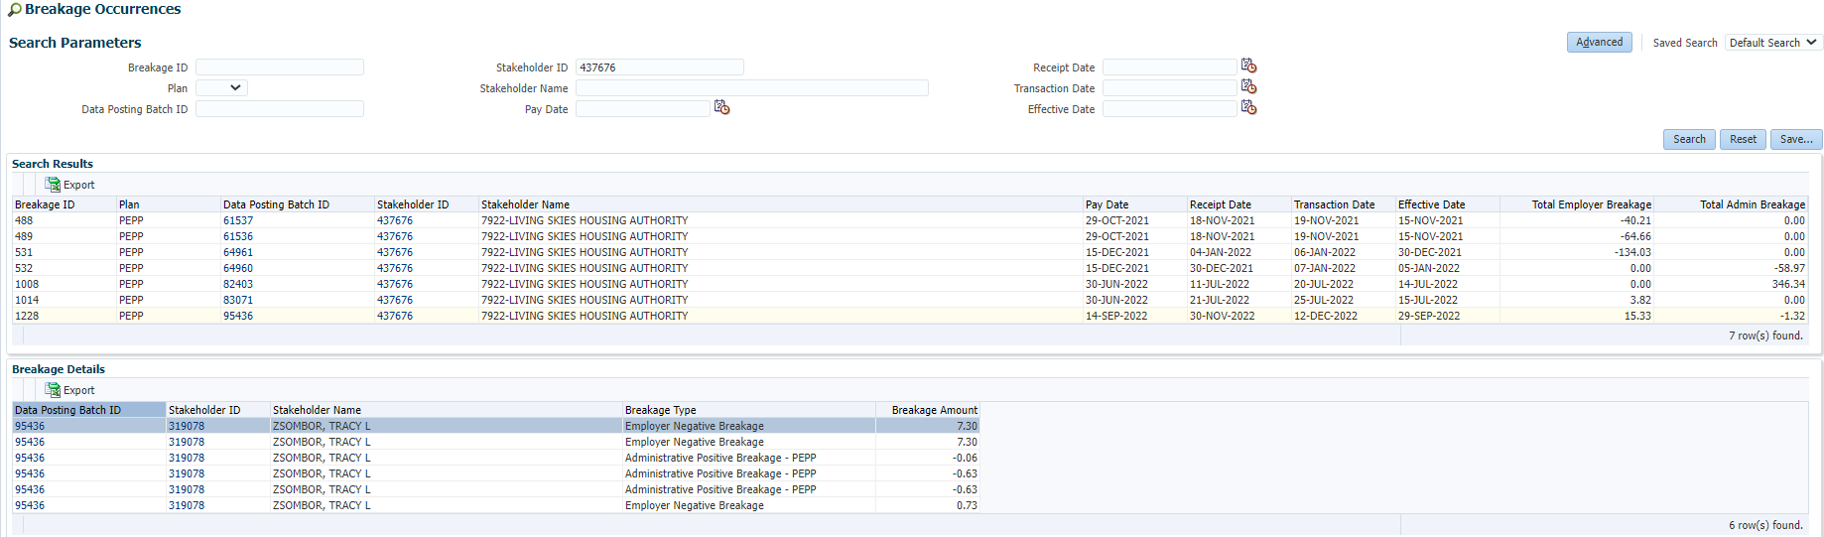

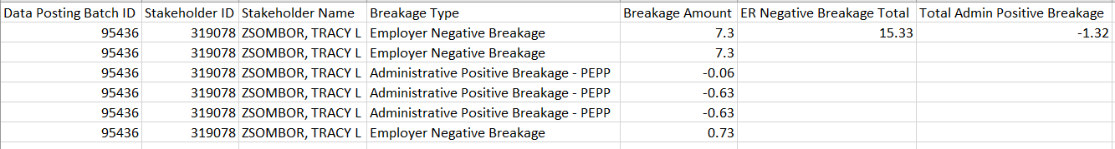

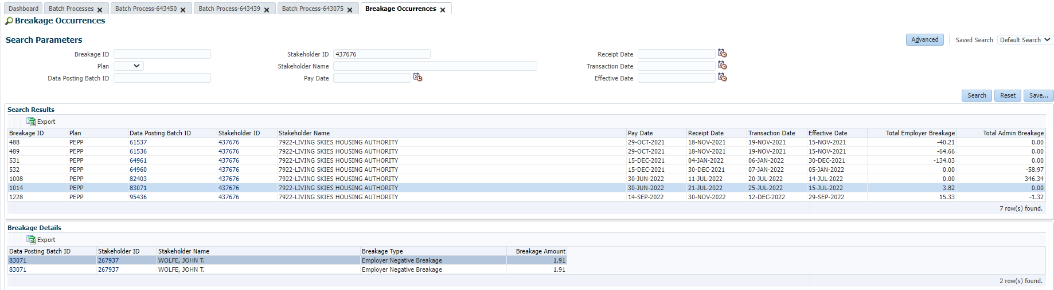



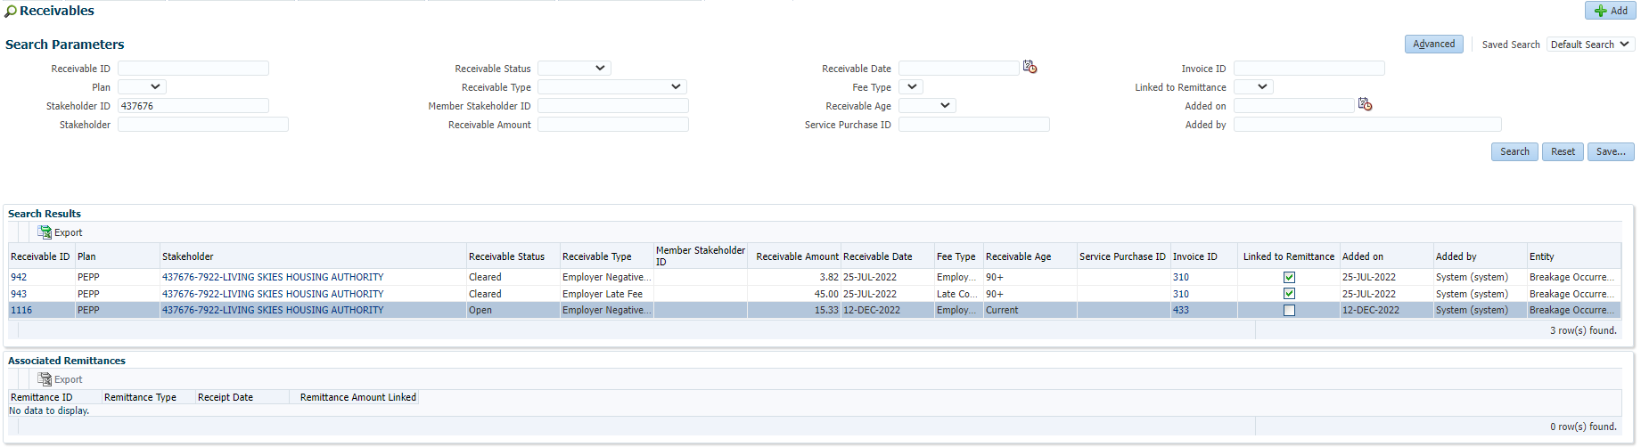

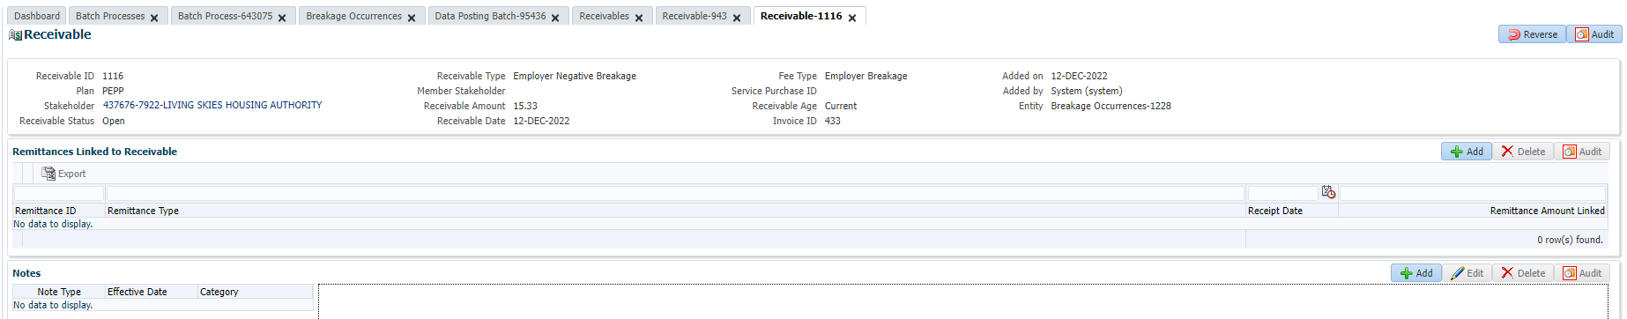

In the letter portion of the Invoice Letter #6, the total of the breakage plus late fee shows $64.15.

In my calculation, that is the ER Negative Breakage from the first instance of $3.82 plus the ER Negative Breakage from the second instance of $15.33 totaling $19.15 plus one $45.00 Late Fee = $64.15. This should include 2 late fees and therefore should show a total of $109.15.

In the Invoice portion, there is 1 Breakage Occurrence listed, which is correct for this occurrence, for a total of $15.33 and no Breakage Fee, resulting in the Invoice amount due of $15.33.

The Late Fee of $45.00 was not included in this invoice and should have been, and the total Invoice amount due should be $60.33

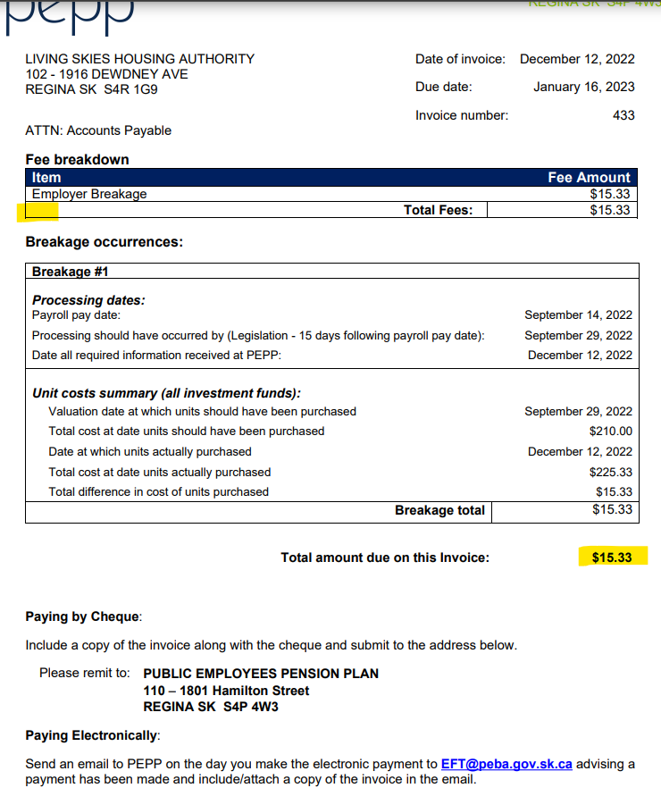

Scenario #2 Executive Government:

There are 3 occurrences of Breakage for Receipt Date 12-Dec-2022:

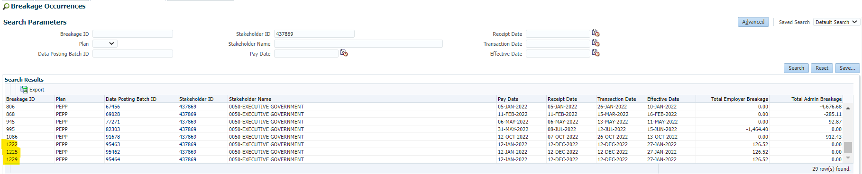

Breakage ID 1222:

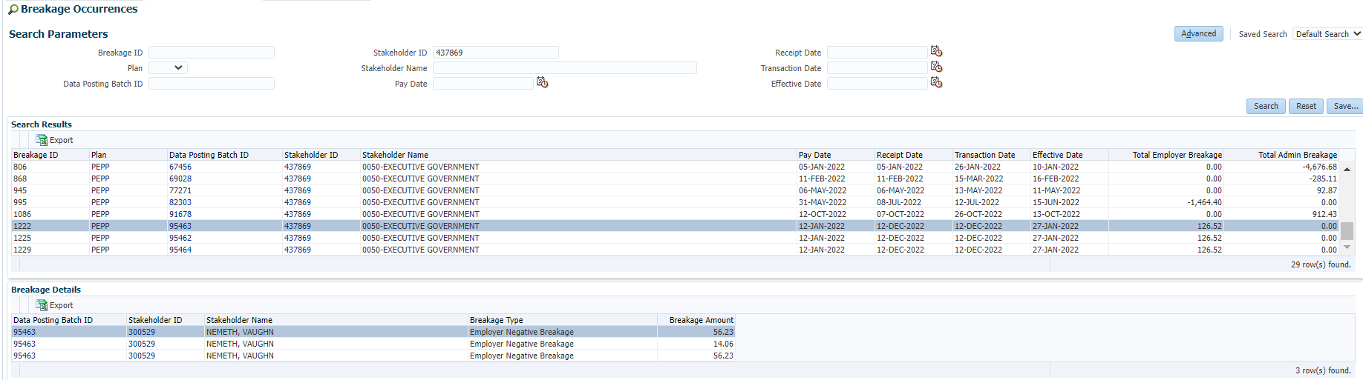

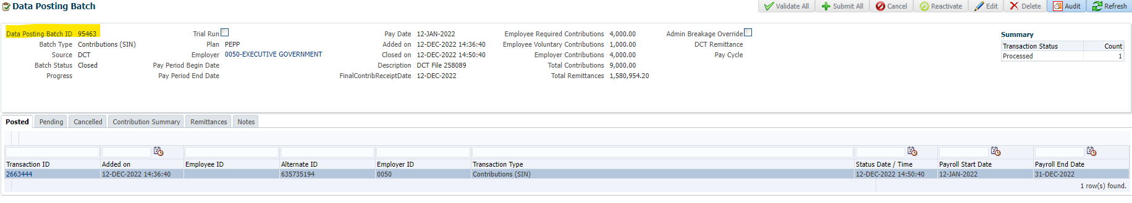

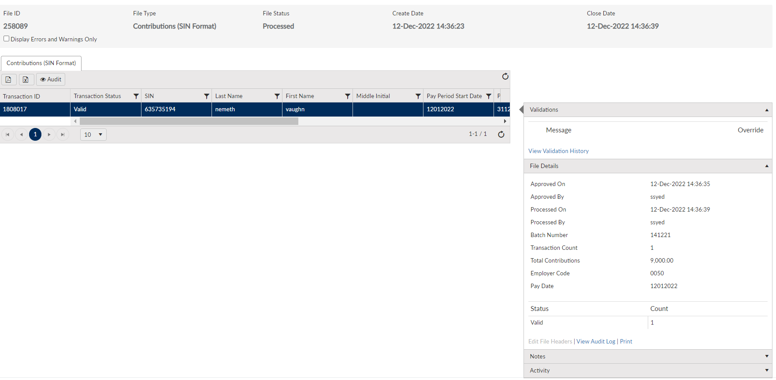

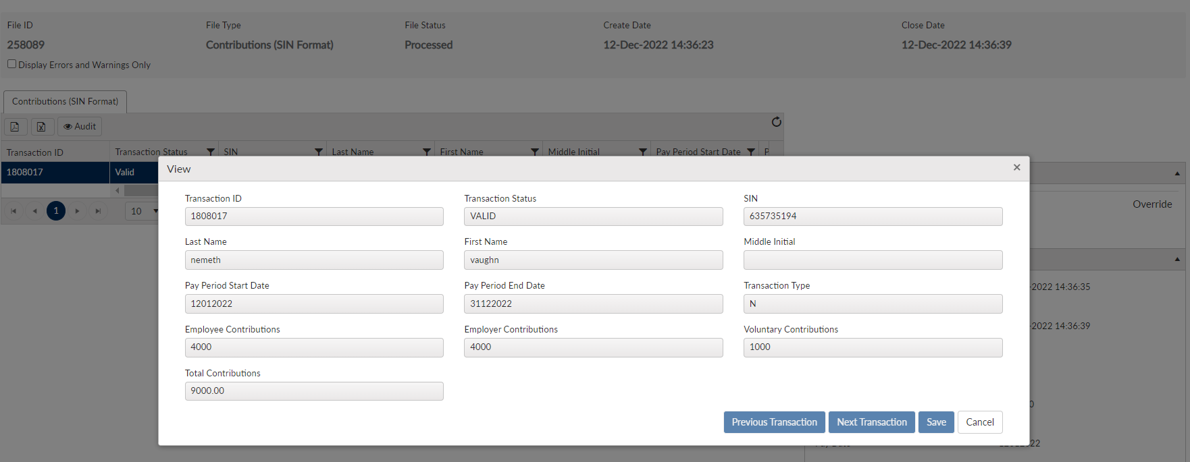

Breakage ID 1225:

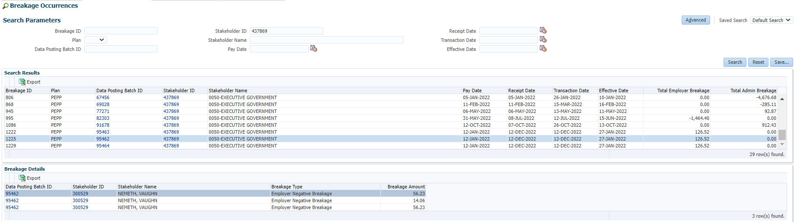

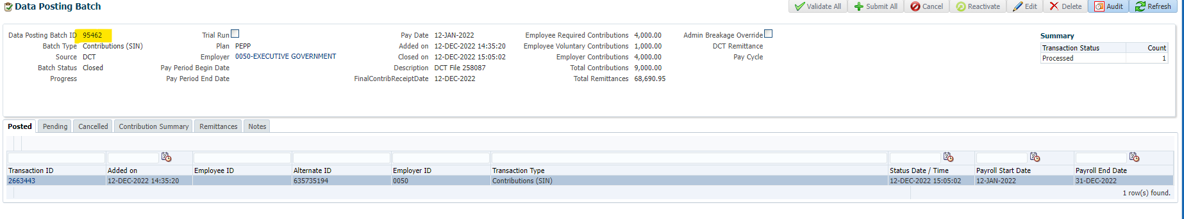

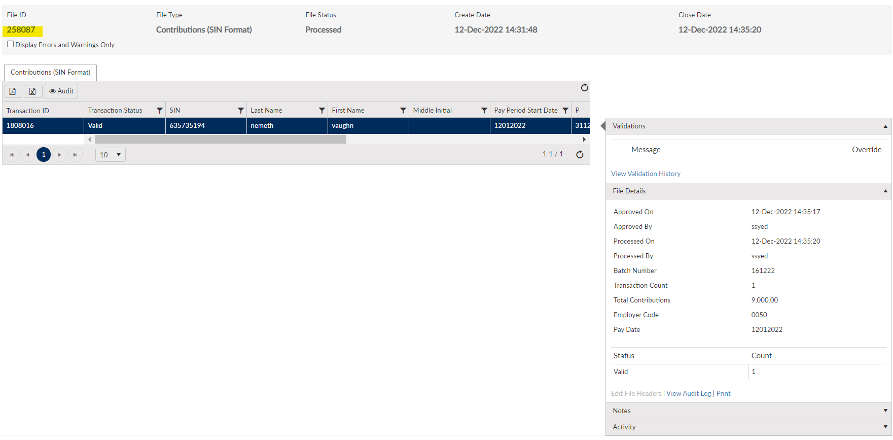

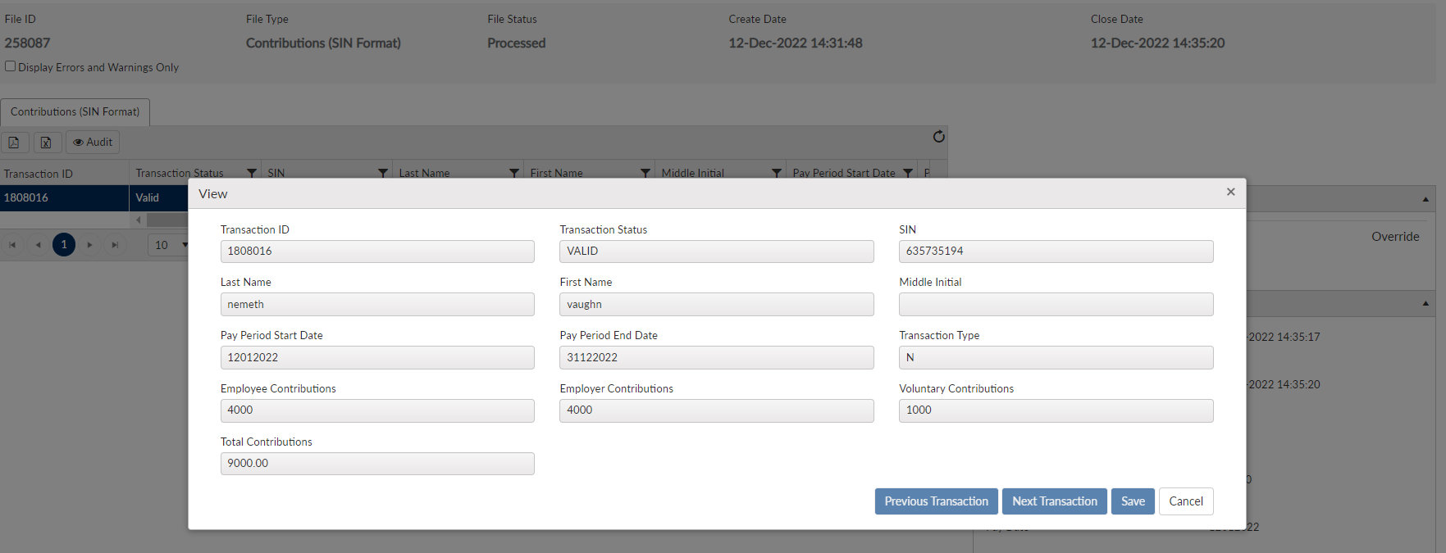

Breakage ID 1229:

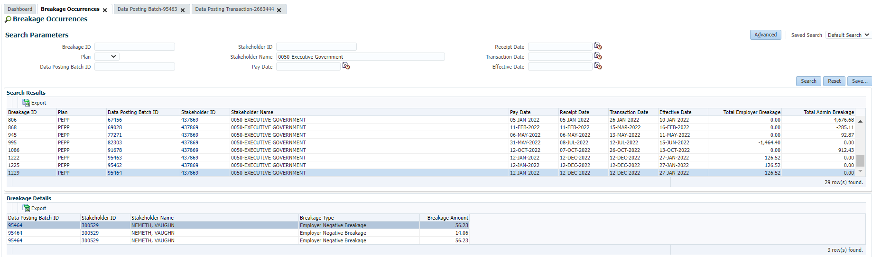

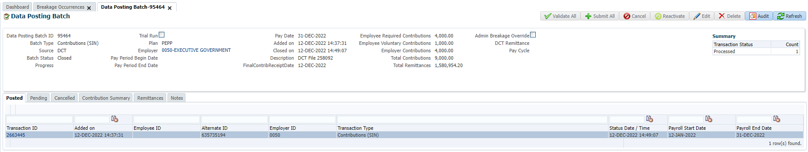

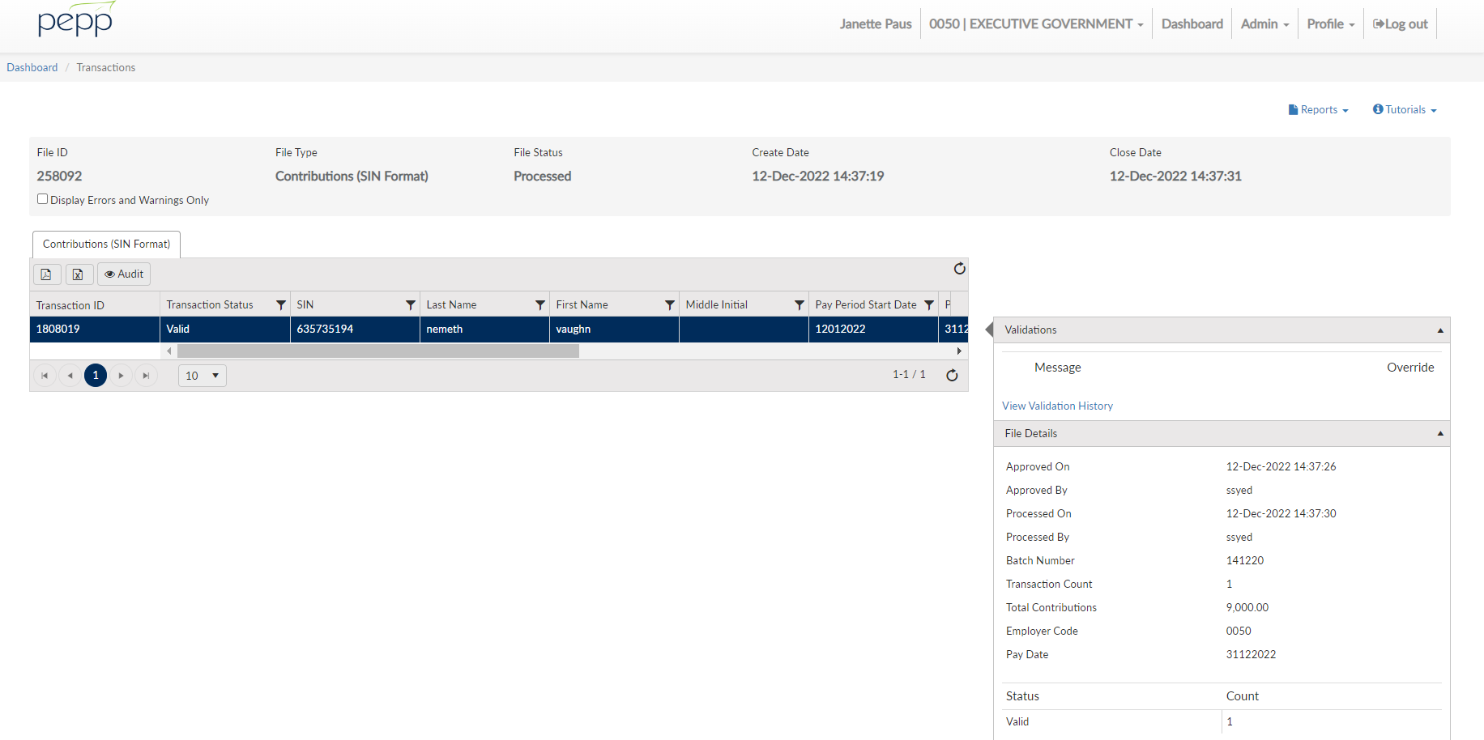

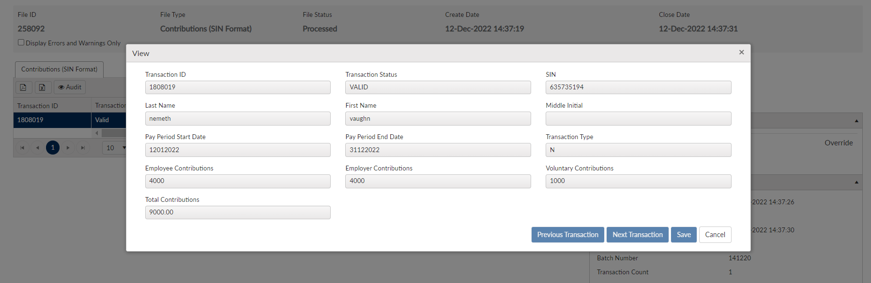

The letter correctly advises 3 occurrences of Breakage and the amount but it appears there is only one Administrative (Late) Fee of $45.00 included in the total (379.56 + 45.00 = 424.56) The Administration Fee is not included in the Invoice, the total amount due is $379.56.

There should be a $45.00 Administrative (Late) Fee for each of these occurrences, so the total in the letter and the Total amount due in the invoice should be $514.56, (3 x 126.52 = 379.56) + (3 x 45 = 135).

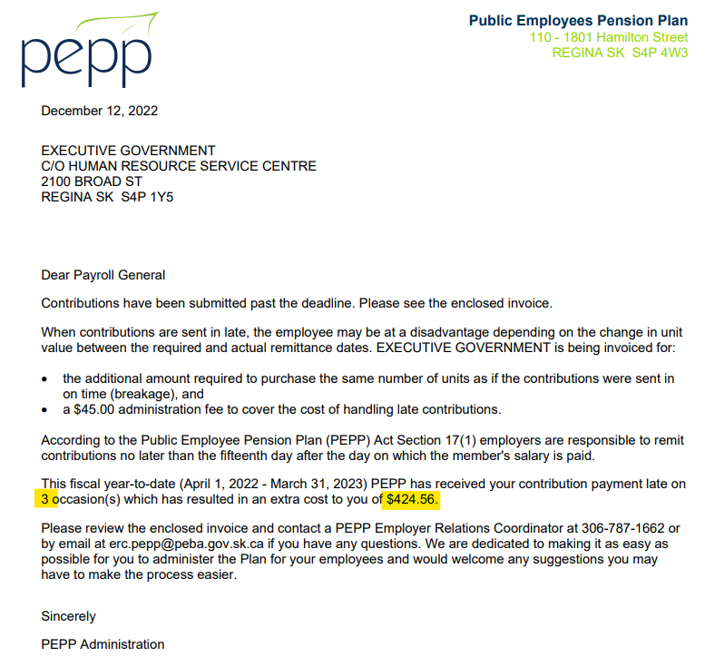

The late fee is missing from this letter and from the ‘Total amount due on this Invoice’.

